**Design of College Webpage**

Mini Modelling Project Report

Submitted by

|  |  |
| --- | --- |
| Name | Class/Roll No |
| Sachin Mane | A-28 |
| Naveen Menon | A-29 |
| Arbaz Naikude | A-30 |
| Divyank Nigade | A-31 |
| Aayuka Nirawde | A-32 |

**G.H.Raisoni College Of Engineering & Management,**

**Wagholi,Pune**

(An Autonomous Institute Affiliated to Savitribai Phule University) Department of F.Y.Btech (Sem II 2016-17)

Under the Supervision of

**Professor. Kirti Amresh**

**G.H.R.C.E.M, Wagholi Pune**

**C E R T I F I C A T E**

This is to certify that Mini Model Project report titled ‘Design of College Webpage’ is a bonafide work carried out by

1. Sachin Mane
2. Naveen Menon
3. Arbaz Naikude
4. Divyank Nigade
5. Aayuka Nirawade

Of our **G.H.RAISONI COLLEGE OF ENGINEERING & MANAGEMENT,WAGHOLI,PUNE**(Department of F.Y.Btech-Sem-II 2016-17) for fulfilment of Project Work.He/She has worked under our guidance and supervision.The material referred from other sources has been duly acknowledged.

(Signature of Faculty)

Name-

Designation-

Date-

Place-

**ACKNOWLEDGEMENT**

The most sincere thanks and gratitude to the Almighty god who has erased the difficulty and cleared the ambiguity for us to fulfil this achievement which is my first year project

First of all. We would like to say that it has been my honour to be students of Prof. Kirti Amresh and also, we would like to thank her to be our mini model project supervisor. We would like to thank her for the guidance, support and encouragement she provided to us throughout the entire duration while we were doing and preparing our project.

We also would like to take a moment to thank our dean sir, Dr R.V.Suryavanshi for the support and guidance he showed towards us throughout the journey whenever we needed him.

Last but not the least, we would like to thank our parents and friends who were there for the constant support and encouragement they showed us throughout our project

**Abstract**

A website is a collection of Web pages, images, videos and other digital assets that is hosted on one or several Web server, usually accessible via the Internet, Mobile phone or a LAN. The pages of websites can usually be accessed from a common root URL called the homepage, and usually reside on the same physical server. The URLs of the pages organize them into a hierarchy, although the hyperlinks between them control how the reader perceives the overall structure and how the traffic flows between the different parts of the sites. The college website has been developed using ASP.Net as the Front End and SQL Server as the Back End. It follows the three tier architecture with C# for coding and ADO.Net providing the classes for database connectivity. The webpages of websites can usually be utilized from a common main URL known as the home-page, and usually live on the same physical hosting server. The URLs of the webpages arrange them into a framework, although the back-links between them control how people thinks the overall framework and how the traffic moves between the different areas of sites. The higher education web page has been designed using ASP.Net as the Front side End and SQL Server as the Back End. It follows the three level framework with C# for programming and ADO.Net offering the sessions for data source connection.

**INDEX**

|  |  |
| --- | --- |
| **Abstract** | **Page Number** |
| 1. **Introduction**   **I.I About the Project & System**  **I.II Problems related to Program**  **I.III Benefits & Future Scope** |  |
| 1. **Development of Website**   **II.I Tags, Descriptions, Links**  **II.II HTML Attributes examples** |  |
| 1. **Outlook of our Webpage** |  |
| 1. **Conclusion**   **IV.I Result**  **IV.II Biblography** |  |

**Introduction**

A website is a collection of [Web pages,](http://en.wikipedia.org/wiki/Web_page) images, videos and other digital assets that is hosted on one or several [Web server,](http://en.wikipedia.org/wiki/Web_server) usually accessible via the [Internet,](http://en.wikipedia.org/wiki/Internet) [cell phone](http://en.wikipedia.org/wiki/Cell_phone) or a [LAN.](http://en.wikipedia.org/wiki/LAN)

The pages of websites can usually be accessed from a common root [URL](http://en.wikipedia.org/wiki/URL) called the [homepage,](http://en.wikipedia.org/wiki/Homepage) and usually reside on the same physical server. The URLs of the pages organize them into a hierarchy, although the [hyperlinks](http://en.wikipedia.org/wiki/Hyperlink) between them control how the reader perceives the overall structure and how the [traffic](http://en.wikipedia.org/wiki/Web_traffic) flows between the different parts of the sites.

A website requires attractive design and proper arrangement of links and images, which enables a browser to easily interpret and access the properties of the site. Hence it provides the browser with adequate information and functionality about the organization, community, network etc.

ABOUT THE PROJECT

The website has been developed for our college (G.H.R.C.E.M) in an effort to make it as attractive and dynamic as possible. Compared to the existing site a database has been added to our project.

The working of the project is as follows.

The first page provides several links. The Home page contains several information about the site like campus, management, facilities, infrastructure etc.

User Login module helps the user to login to the site. For that he must type the username and password correctly. The login provision in this page helps the already registered user to directly access the site and there is a link for registration to a user who is new to this site.

Member Registration module helps the new user to register into the site. The information entered by the users is added into the table registration.

The flash news and the events corner display the latest developments, announcements and events associated with the college activities.

The administrator has the responsibility for displaying the recruiters form on the notice board, in response to which student can submit his willingness to attend the drive along with his resume.

EXISTING SYSTEM

The existing college website is static which makes it less interactive. It doesn't have a database connectivity. Moreover students didn't have an access to the details of the college through the site, hence they were not updated about the latest events and placement drives.

PROPOSED SYSTEM

In order to make the site dynamic and more interactive we have tried to include a database link to our college website. Hence the recruiters have been provided with the facility to post their eligibility criteria, vacancies and salary packages. In response to which a student can submit his willingness to appear for the drive along with his personal details. Provision has also been made to display the latest events and announcements associated with the college online. We have developed our project using the three tier architecture which uses the following languages.

**Introduction to CSS(cascading style sheets)**

[CSS.NET](http://ASP.NET) is not just a simple upgrade or the latest version of CSS. [CSS.NET](http://ASP.NET) combines unprecedented developer productivity with performance, reliability, and deployment. [CSS.NET](http://ASP.NET) redesigns the whole process. It's still easy to grasp for new comers but it provides many new ways of managing projects. Below are the features of [CSS.NET](http://ASP.NET).

• Easy Programming Model

[CSS.NET](http://ASP.NET) makes building real world Web applications dramatically easier. [CSS.NET](http://ASP.NET) [server controls](http://www.startvbdotnet.com/aspsite/asp/features.aspx) enable an HTML-like style of declarative programming that let you build great pages with far less code than with classic CSS. Displaying data, validating user input, and uploading files are all amazingly easy. Best of all, [CSS.NET](http://ASP.NET) pages work in all browsers including Netscape, Opera, and Internet Explorer.

**Problems related to creating a website**

**Website accessibility:** The Web is basically designed to work for all people, irrespective of the culture, language, location, or physical or mental ability. However, one of the major challenges a web designer faces is to enhance the accessibility of websites. A good designer should ensure that the website is not only accessible across the world but also its various features are fully functional as well.

**Compatibility with browsers:** With the introduction of different browsers, designers are constantly facing the challenge of building a website which is compatible with almost all the major browsers. After designing a website, it should be tested on all browsers to ensure that the website is completely functional.

**Positioning of content:** Another aspect of a website is that the users should find it readable. While designing the structure of the website, the designer should place the content in such a manner that it enhances easy reading. In addition, use suitable colors when it comes to font.

## Benefits of CSS in Web Development

##### Improves Website Presentation

The standout advantage of CSS is the added design flexibility and interactivity it brings to web development. Developers have greater control over the layout allowing them to make precise section-wise changes.

As customization through CSS is much easier than plain HTML, web developers are able to create different looks for each page. Complex websites with uniquely presented pages are feasible thanks to [CSS](http://www.w3schools.com/css/).

##### Makes Updates Easier and Smoother

CSS works by creating rules. These rules are simultaneously applied to multiple elements within the site. Eliminating the repetitive coding style of [HTML](http://www.w3schools.com/html/) makes development work faster and less monotonous. Errors are also reduced considerably.

Since the content is completely separated from the design, changes across the website can be implemented all at once. This reduces delivery times and costs of future edits.

##### Helps Web Pages Load Faster

Improved website loading is an underrated yet important benefit of CSS. Browsers download the CSS rules once and cache them for loading all the pages of a website. It makes browsing the website faster and enhances the overall user experience.

This feature comes in handy in making websites work smoothly at lower internet speeds. Accessibility on low end devices also improves with better loading speeds.

**Development of a website**

It is important that your web designer start off by asking a lot of questions to help them understand your business and your needs in a web site.

Certain things to consider are:

Purpose

What is the purpose of the site? Do you want to provide information, promote a service, sell a product… ?

Goals

What do you hope to accomplish by building this web site? Two of the more common goals are either to make money or share information.

Target Audience

Is there a specific group of people that will help you reach your goals? It is helpful to picture the “ideal” person you want to visit your web site. Consider their age, sex or interests – this will later help determine the best design style for your site.

Content

What kind of information will the target audience be looking for on your site? Are they looking for specific information, a particular product or service, online ordering…?

The developmental stage is the point where the web site itself is created. At this time, your web designer will take all of the individual graphic elements from the prototype and use them to create the actual, functional site.

This is typically done by first developing the home page, followed by a “shell” for the interior pages. The shell serves as a template for the content pages of your site, as it contains the main navigational structure for the web site. Once the shell has been created, your designer will take your content and distribute it throughout the site, in the appropriate areas.

This entire time, your designer should continue to make your in-progress web site available to you for viewing, so that you can suggest any additional changes or corrections you would like to have done.

On the technical front, a successful web site requires an understanding of front-end web development. This involves writing valid HTML / CSS code that complies to current web standards, maximizing functionality, as well as accessibility for as large an audience as possible.

A good web designer is one who is well versed in current standards for web site design and development. The basic technologies currently used are HTML and CSS (Cascading Style Sheets). As part of testing, your designer should check to be sure that all of the code written for your web site validates. Valid code means that your site meets the current web development standards – this is helpful when checking for issues such as cross-browser compatibility as mentioned above.

Once you give your web designer final approval, it is time to deliver the site. An FTP (File Transfer Protocol) program is used to upload the web site files to your server. Some web designers offer domain name registration and web hosting services as well, or have recommendations as to where you can host your site. Once these accounts have been setup, and your web site uploaded to the server, the site should be put through one last run-through. This is just precautionary, to confirm that all files have been uploaded correctly, and that the site continues to be fully functional.

Other final details include plugin installation (for WordPress or other CMS driven web sites and SEO (Search Engine Optimization). SEO is the optimization of your web site with elements such as title, description and keyword tags which help your web site achieve higher rankings in the search engines. The previously mentioned code validation is something that plays a vital role in SEO, as well. There are many WordPress plugins available that further enhance the default WordPress functionality – many of which directly relate to improving your SEO, as well.

There are a lot of details involved in optimizing your web site for the search engines – enough to warrant its own post. This is a very important step, because even though you now have a web site, you need to make sure that people can find it!

Title Tags

Title tags are one of the most important factors related to on-page search engine optimization. Title tags, also known as meta titles, appear on the search engine results page and make a big difference in whether or not a potential visitor will click on your listing. Be sure each web page on your site has an original title tag that represents its unique value and purpose within your overall site architecture. Also keep in mind that your title tags should be limited to approximately 65 characters (including spaces). You can identify your title tags by right clicking and choosing “View Page Source,” or you may consider downloading the Web Developer Add-On, which also comes in handy for viewing meta descriptions.

Meta Descriptions

While meta descriptions don’t have a direct bearing on your search engine rankings, they play a critical role in the split-second decision a visitor makes regarding whether or not to click on your website listing in the search engine results. Use the allotted space for meta descriptions (approximately 156 characters) to provide a succinct description of your webpage. It also doesn’t hurt to include a call to action in your meta description — this could make the difference between a click or no click. As with title tags, each page on your website should have a unique meta description.

Links

Search engines use the number of links to a website as an indicator of its importance. The more sites that link to you, the better you will rank in search engines. Keep in mind; you want to earn quality links from websites that are relevant, trustworthy, and well-ranked.

So how do you know which links are currently pointing to your website? There are a lot of tools that provide backlink data. Take a look at Google Webmaster Tools to view a list of the sites that link to your website. Other recommended tools include Open Site Explorer or ahrefs. Both Open Site Explorer and ahrefs provide you with a limited amount of information without requiring a paid membership.

It’s hard to answer the question — how many backlinks are “good?” It really depends on the size of your website and the type of business you’re running. Take a look at how many links you have right now, and then set a goal for yourself to increase the number of links per month by a certain percentage rather than a hard number. Make sure you’re not buying links, that you’re not buying social points, and that you’re not dealing with link farms. Search engines are really looking for quality of links versus quantity.

Anchor Text

Anchor text is simply the characters and words that a hyperlink is embedded in when linking to another document or location on the web. Search engines use anchor text to help them figure out what the hyperlinked page is about and who it may be relevant for. Optimize links so that rather than using “Read More” and “Learn More,” you have target keywords in the anchor text. So instead of: “Concierge Preferred is a great resource for things to do in Chicago. Read more here”; use something like “Concierge Preferred has a great article on things to do in Chicago.” Optimizing your anchor text is something you or your webmaster can do right away, and it makes a big difference. However, DO NOT try and manipulate your anchor text for the purpose of SEO. The anchor text MUST be natural and should act as a directional indicator that benefits the reader more than the search engine.

JavaScript

Take a look at your website from the point of view of a search engine. Disabling JavaScript helps you see your site the same way search engines see it, since they have a more difficult time reading JavaScript than HTML. A small amount of users may have JavaScript disabled, either for speed, security or accessibility reasons. You can download another helpful tool, the MozBar, to quickly turn JavaScript off and on.

Take a look at your website with JavaScript disabled. What changes? Do your navigation menus still work? Do your videos disappear? How about your content? If your website offers a significantly different experience with JavaScript turned off, it may be time to consider alternates to JavaScript.

Canonical URL Check

To a search engine, “mywebsite.com” and “www.mywebsite.com” are not the same thing. Enter your website into a browser with and without http:// and with and without www, and see what happens. If you don’t see that all your traffic is redirecting to a single page, you have a canonicalization issue and likely a duplicate content problem. Set up a 301 redirect to correct these issues.

It should go without saying that the items above are just a brief entry point into a comprehensive website analysis, but they all make up pieces of the bigger puzzle that is search engine optimization. Take a closer look at these important website elements, and make sure you understand how each of these items relates to your website’s search engine rankings. Stay tuned to our blog for future tips on analyzing your website.

**Inserting Images**

In HTML, images are defined with the **<img>** tag.

The <img> tag is empty, it contains attributes only, and does not have a closing tag.

The src attribute specifies the URL (web address) of the image:

<img src="*url*" alt="*some_text*" style="width:width;height:height;">

## The alt Attribute

The alt attribute provides an alternate text for an image, if the user for some reason cannot view it (because of slow connection, an error in the src attribute, or if the user uses a screen reader).

If a browser cannot find an image, it will display the value of the alt attribute:

You can use the **style** attribute to specify the width and height of an image.

The values are specified in pixels (use px after the value):

### **Example**

<img src="html5.gif" alt="HTML5 Icon" style="width:128px;height:128px;">

Alternatively, you can use the **width** and **height** attributes. Here, the values are specified in pixels by default:

### **Example**

<img src="html5.gif" alt="HTML5 Icon" width="128" height="128">

HTML5 Attributes

HTML5 added the following attributes for <input>:

* autocomplete
* autofocus
* form
* formaction
* formenctype
* formmethod
* formnovalidate
* formtarget
* height and width
* list
* min and max
* multiple
* pattern (regexp)
* placeholder
* required
* step

and the following attributes for <form>:

* autocomplete
* novalidate

## Using HTML Geolocation

The getCurrentPosition() method is used to return the user's position.

The example below returns the latitude and longitude of the user's position:

* Check if Geolocation is supported
* If supported, run the getCurrentPosition() method. If not, display a message to the user
* If the getCurrentPosition() method is successful, it returns a coordinates object to the function specified in the parameter (showPosition)
* The showPosition() function outputs the Latitude and Longitude

Geolocation is also very useful for location-specific information, like:

* Up-to-date local information
* Showing Points-of-interest near the user
* Turn-by-turn navigation (GPS)

**Chapter 3: Outlook of our Website**

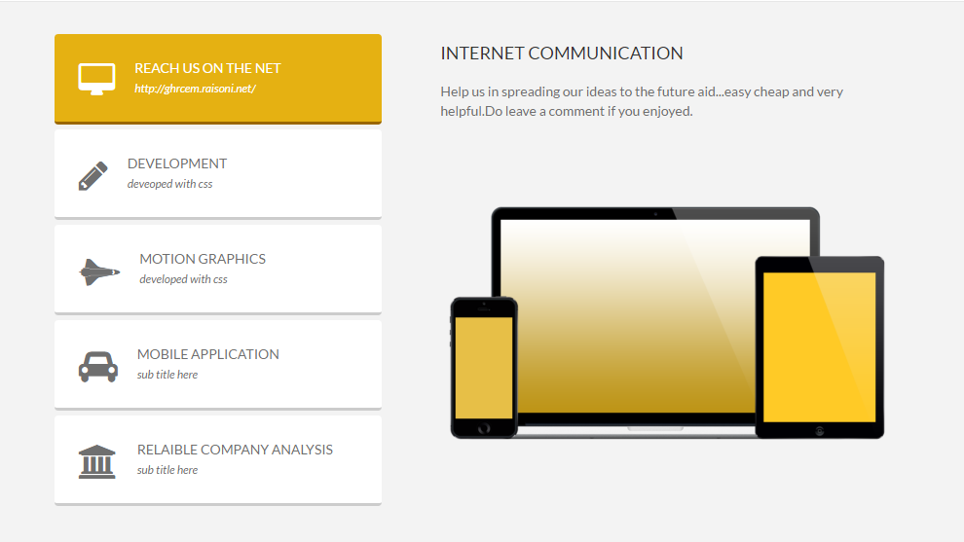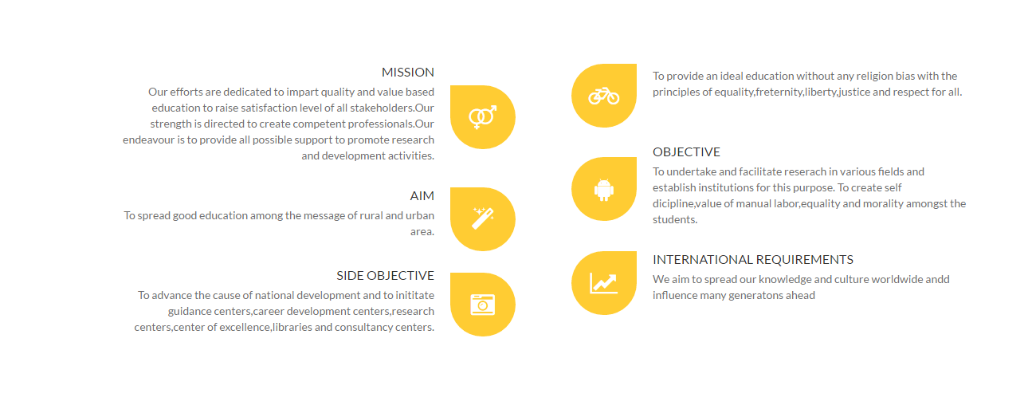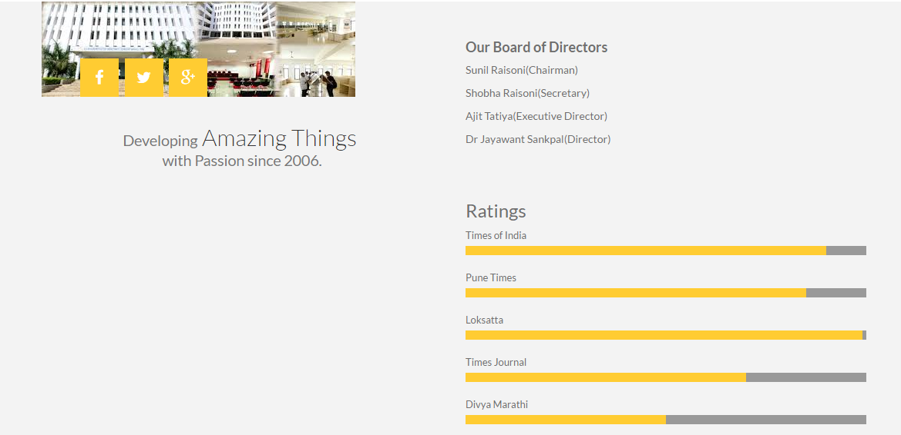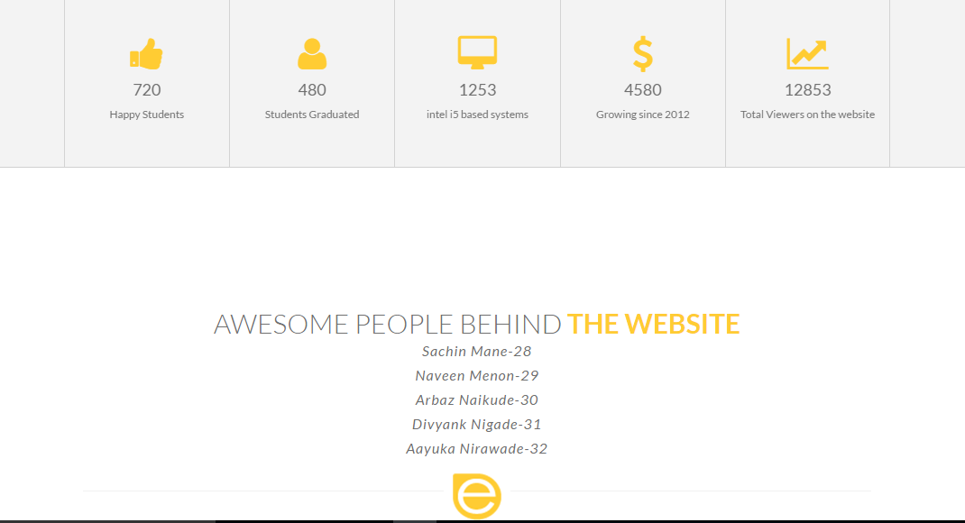

**The Conclusion**

The project report entitled "COLLEGE WEBSITE CREATION" has come to its final stage. The system has been developed with much care that it is free of errors and at the same time it is efficient and less time consuming. The important thing is that the system is robust. We have tried our level best to make the site as dynamic as possible. Also provision is provided for future developments in the system. The entire system is secured. This online system will be approved and implemented soon

The developed system is flexible and changes can be made easily. The system is developed with an insight into the necessary modification that may be required in the future. Hence the system can be maintained successfully without much rework.

One of the main future enhancements of our system is to include student record that facilitates quick and easy retrieval of student details. Scope has aloes be made to add a link to the library

References

* Blanck, Peter. eQuality: The Struggle for Web Accessibility by Persons with Cognitive Disabilities, Cambridge Disability Law and Policy Series, 2015.
* Burgstahle, Sheryl. Universal Design in Higher Education: From Principles to Practice, Harvard Education Press, 2008.
* Byrne, Jim. 60 hot to touch Accessible Web Design tips – the tips no web developer can live without!, Jim Byrne, 2006, (ISBN: 978-1-4116-6729-7).
* Chisholm, and May. Universal Design for Web Applications: Web Applications That Reach Everyone, O'Reilly Media, 2008.
* Clark, Joe. Building Accessible Websites, New Riders Publishing, 2002.
* Coombs, Norman. Making Online Teaching Accessible, Jossey-Bass, 2010. ["Making Online Teaching Accessible" is downloadable from Bookshare](http://www.bookshare.org/browse/book/257531?returnPath=L3NlYXJjaD9rZXl3b3JkPURyLiBOb3JtYW4gQ29vbWJzJnNlYXJjaD1TZWFyY2gm).
* Cunningham, Katie. The Accessibility Handbook, O'Reilly Media, 2012.
* Duckett, Jon. AccessibleXHTMLandCSSWeb Sites Problem Design Solution, Wrox, 2005.
* Hassell, Jonathan. Including your missing 20% by embedding web and mobile accessibility, BSI British Standards Institution, 2014.
* Henry, Shawn Lawton. Just Ask: Integrating Accessibility Throughout Design, ET\Lawton, 2007.
* Horton, Sarah and Quesenbery, Whitney. Universal Design for Web Accessibility, Rosenfeld Media, 2014.
* Horton, Sarah and Quesenbery, Whitney. A Web for Everyone, Rosenfeld Media, 2012.
* Horton, Sarah. Access by Design: A Guide to Universal Usability for Web Designers, New Riders Publishing, 2005.
* Hricko, Mary (Editor). Design and Implementation of Web-Enabled Teaching Tools, Idea Group Publishing, 2002.
* Kline, Jeff. Strategic IT Accessibility: Enabling the Organization, Live Oak Book Company, 2011.
* Kirkpatrick, Andrew et al. Web Accessibility: Web Standards and Regulatory Compliance, friends of ED, 2006.
* Kouznetsova, Svetlana. Sound Is Not Enough: Captioning as Universal Design, Svetlana Kouznetsova, 2015.
* Meloncon, Lisa. Rhetorical AccessAbility: At the Intersection of Technical Communication and Disability Studies, Baywood Publishing Company Inc., 2013.
* O Connor, Joshue. Pro HTML5 Accessibility, Apress, 2012.
* Pickering, Heydon. Apps For All: Coding Accessible Web Applications, Smashing Magazine GmbH, 2014.
* Pickering, Heydon. Inclusive Design Patterns, Smashing Magazine, 2016.
* Sydik, Jeremy. Design Accessible Web Sites, Pragmatic Bookshelf, 2007.
* Thatcher, Jim et al. Constructing Accessible Web Sites, Glasshaus, 2002.
* Thatcher, Jim et al. Web Accessibility: Web Standards and Regulatory Compliance, friends of ED, 2006.
* Paciello, Michael G. Web Accessibility for People With Disabilities, CMP Books, 2000.
* Seale, Jane. E-learning and Disability in Higher Education, Routledge, 2014.
* Slatin, John M. and Rush, Sharron. Maximum Accessibility: Making Your Web Site More Usable for Everyone, Addison Wesley Professional, 2002.
* Watson, Leonie et al. Practical Approaches For Designing Accessible Websites, Smashing Magazine GmbH, 2015. (ISBN (EPUB: 978-3-945749-23-4).
* Yonaitis, Robert B. Understanding Accessibility, HiSoftware Publishing, 2002.